UID EXPERIMENT – 4b
Name: M.K.Raghavan ROLL NO.: 240701408

Title:
Prototype Design with Familiar and Unfamiliar Navigation using Wireflow

AIM:
To design a prototype with both familiar and unfamiliar navigation elements and evaluate ease of use among different user groups using Wireflow.

TOOLS USED:
Wireflow
1. Login Screen (User Authentication Interface)
The Login Screen is the entry point of the application where users authenticate themselves.
- UI Elements Used:
  - Text fields for Email and Password
  - Login button (primary action)
  - “Forgot Password” and “Sign Up” links
  - Profile icon for visual appeal
- Design Principles:
  - Simplicity: Minimal elements to avoid confusion
  - Clarity: Clearly labeled input fields
  - Consistency: Standard login pattern used in most apps
- User Experience:
  - Users can quickly understand how to log in
  - Familiar layout reduces cognitive load
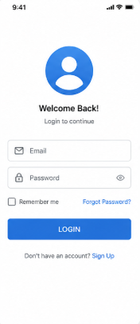
2. Home Screen (Familiar Navigation Interface)
The Home Screen provides access to main features using well-known navigation patterns.
- UI Elements Used:
  - Search bar for quick product search
  - Category icons (Electronics, Fashion, etc.)
  - Product listings
  - Bottom navigation bar
- Design Principles:
  - Visibility: Important features are easily visible
  - Accessibility: Navigation is easy using bottom bar
  - Consistency: Standard e-commerce layout
- User Experience:
  - Users can browse and search products easily
  - Familiar navigation improves efficiency and speed
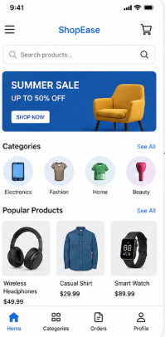
3. Explore Screen (Unfamiliar Navigation Interface)
The Explore Screen introduces innovative navigation to test user adaptability.
- UI Elements Used:
  - Circular floating buttons (Trending, Categories, Deals, For You)
  - Gesture-based interaction (drag/tap)
  - Minimal text interface
- Design Principles:
  - Innovation: Uses non-traditional navigation style
  - Engagement: Interactive elements attract user attention
  - Exploration: Encourages users to discover features
- User Experience:
  - May be interesting and visually appealing
  - Can confuse first-time users due to lack of familiarity
  - Requires learning effort
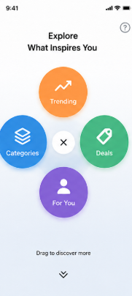
4. Profile Screen (User Information & Settings Interface)
The Profile Screen allows users to manage personal data and settings.
- UI Elements Used:
  - User profile picture and details
  - List of options (Orders, Wishlist, Address, Payment)
  - Logout option
- Design Principles:
  - Organization: Information arranged in a structured list
  - Consistency: Uses common settings layout
  - Usability: Easy to access important user functions
- User Experience:
  - Users can easily manage account details
  - Clear navigation reduces errors
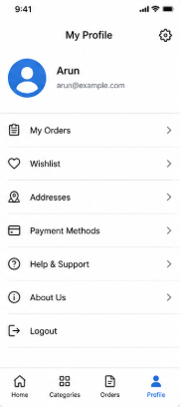
RESULT
The prototype with both familiar and unfamiliar navigation elements was successfully designed and implemented using Wireflow. The user flow between the Login, Home, Explore, and Profile screens was clearly established and tested.

